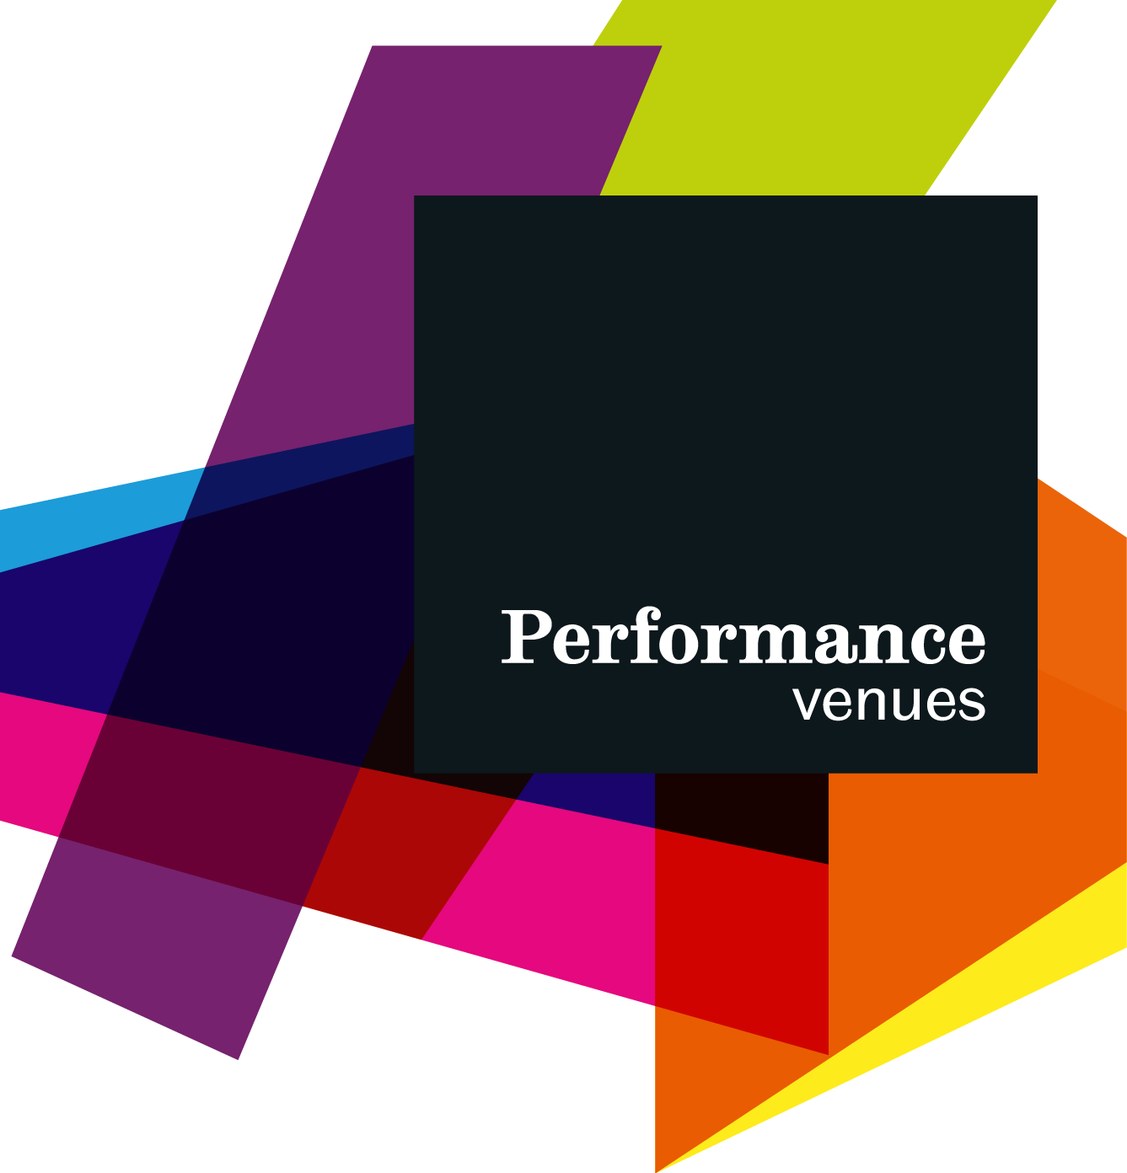
CREATIVE ARTS ADMINISTRATION DEVELOPMENT SCHEME (CAADS)
Recruitment Information and Application Form

1 | ABOUT PERFORMANCE VENUES

Performance Venues

Performance Venues is a section within Estates and Facilities Management that operates 3 venues on Campus - the Octagon Centre, Firth Hall and the Drama Studio. Alongside conferences, students union and university events, the venues host a range of exciting live performing arts and music events. Our two curated programmes are University of Sheffield Concerts and Enable US Project.

University of Sheffield Concerts

University of Sheffield Concerts is a home for musical discovery, learning, and participation. We combine eclectic programming, internationally renowned performers, and creative learning opportunities in a dynamic music event series. We exist to provide inspiration and support for student creativity, a platform for research-led events, and as a means to bring public audiences in contact with outstanding performances and learning experiences.

Enable US
The Enable US Project was started in 2017. It provides a platform within the University of Sheffield Performance Venues to bring audiences, artists and the University community together to experience, inspire and be inspired by dance, comedy and physical theatre performances. It programmes performances to stimulate thought and broaden understanding, as well as providing access to workshops, training and development.

2 | ABOUT CAADS
Performance Venues is committed to career development and our popular internship scheme benefits students from across the institution. CAADS fosters paid opportunities for students to develop skills in arts administration and management in a demanding, outward facing professional context. You will work as part of a highly skilled team, and develop skills in a number of core performing arts management functional areas (marketing, operations, finance, and programming) across a range of projects and outputs. The scheme is a great way to build valuable CV points, and many former participants have entered subsequent employment in arts organisations throughout the UK.

3 | WHAT PREVIOUS PARTICIPANTS HAVE SAID

“As an Intern I learnt a great deal about what goes into the running of a successful concert series. It was an invaluable experience that I enjoyed enormously and it ignited a passion within me to make music management my career.”

“During my time as an Intern I have been able to gain an insight into the organisation behind a successful concert series and work with and alongside music professionals. I have been given the opportunity to develop skills in tasks I previously had little experience with and this has increased my confidence a great deal. The internship has been a great platform on which I hope to build professional experience in the future.”

“As the Intern I gained experience in all the different roles involved in running a concert series, from artist liaison to hosting the front of house. I met so many interesting and important musicians who offered great insight to being a successful musician. Most importantly it helped me decide which direction to go after University, and it stands out on my CV. I really enjoyed the experience and would definitely recommend it.”

“I had previously undertaken a work experience post in the Summer, and I was drawn to the internship with the concert series because it allowed me to specialise in marketing, which I have now gone into as a career. However, the internships are also suitable for those without experience, providing a great introduction to arts administration. My experience as an intern will prove invaluable in securing a job in this area after I graduate”

4 | 2022 -2023 VACANCY
Digital Media Officer

The Digital Media Officer is the voice of Performance Venues and its curated programmes. You will be a champion of the mission and outputs of Performance Venues, Enable US Project and University of Sheffield Concerts connecting artists, audiences, music and the city. The Digital Media Officer will work with the Performance Venues Team to promote our brand, manage our social media accounts and be passionate about music making to develop new, and grow existing audiences to support our work.

Specific responsibilities include:
- Manage social media accounts, creating engaging content which can be posted across our YouTube, Facebook, Instagram and Twitter platforms
- Ensure regular marketing activity (through live posting and advance scheduling)
- Take pictures and videos at selected events and post to social media platforms, and edit and upload student video footage
- Update the Performance Venues website on a regular basis
- Look at trending content which can be used to engage our online communities
- Maintain overview of other relevant social media activity in the city and interact accordingly
- Produce a social media schedule for the season, with weekly schedules to be reviewed in marketing meetings
- Support development of streamed content and oversee live-streamed events
- Support the marketing of streamed events
- Undertake occasional video editing work
- Maintain Facebook events
- Moderate public content and respond to customer enquiries across social media platforms
- Support the Marketing Lead and Music Programme Producer in all marketing activities to ensure box office targets are met for concerts
- Support live concerts and stewarding where required
- Any other duties delegated by more senior team members in support of the continuing operation of Performance Venues’ curated programmes. .

Person Specification:
- Good knowledge and passion towards a wide range of musical genres
- Experience with social media platforms (Twitter, Facebook, Instagram)
- Excellent written communication skills, ability to write succinctly and accurately
- Good attention to detail
- Computer literate, ability to use standard Office, Google and social media systems
- Experience with video editing software (useful but not essential - training will be provided)
- Experience with photo-editing and publishing software eg Canva, Adobe suite (ideal but not essential - training will be provided)
- Excellent organisational skills with a flexible and can-do attitude and approach to work
- Ability to work effectively both independently and as part of a team
- Ability to follow health and safety processes, and willingness to work safely in a public facing environment.
- Enthusiasm for safe working practice and ability to adapt to new objectives quickly and professionally

As this is an internship role, we do not expect candidates to have all of the above skills, and these form only part of our criteria for candidate selection. We will provide training where required on the job.

5 | JOB OUTLINE

Job title: Digital Media Officer
Reports to: Music Programme Producer
Appointment: 2021-22 academic year (with a probationary period and review after Semester 1)
Based in: The role will be based on campus in Performance Venues’ event spaces or the Performance Venues Offices, Octagon Centre, Clarkson Street, Sheffield, S10 2TQ.

Hours: 10 hours a week for 12 weeks in semesters. Specific allocation of hours is flexible and will be tailored around academic commitments.
Pay rate: £11.38 per hour (Grade 3.3)

Deadline for applications - 11pm, Friday 7th October
Interviews will be held on 13th and 14th of October. Start date during week commencing 17th October (dependent on candidate availability).

6a | APPLICATION – PERSONAL DETAILS

[All relevant information to be put on this form, CVs will not be accepted]
Please ensure that you fully complete all sections of the application.
Title: |  | Surname:
Date of birth: |  | Forename:
 |  | Preferred name:
 |  | National Insurance Number:
Address and Postcode: |  | Telephone number(s):  Home:  Mobile:  Email address:
Under the Immigration, Asylum and Nationality Act 2006 proof of entitlement to work in the United Kingdom is required before commencing employment.
Applicants for this role must be eligible to work legally in the United Kingdom. If you do not have the necessary permissions to do so, unfortunately we are unable to consider your application.
Please tick the relevant box to confirm that you have the necessary permissions to work legally in the United Kingdom in the capacity of these posts?

YES ☐

NO ☐

Before commencing employment you will be required to produce original documentary evidence indicating that you have the right to work in the UK, and we will keep copies of the documents.
More information can be found here: https://www.sheffield.ac.uk/ssid/immigration/during-study/work-during-study
If you have any questions, Student Support Information Desk should be able to help you:
https://www.sheffield.ac.uk/ssid

6b | APPLICATION – EDUCATION

Starting with the most recent, please provide details of all qualifications, including details of any current study and predicted results.
Name of educational  establishment | Dates of  attendance | Qualifications obtained, attainments, examinations pending
 |  | Subject/qualification | Result

6c | PREVIOUS EMPLOYMENT AND WORK EXPERIENCE

Starting with the most recent, please provide details of any relevant work experience, employment, and volunteering experience.
Name and address of organisation | Dates of employment, engagement | Job title | Brief description of role/responsibilities

6d | PERSONAL STATEMENT AND SUITABILITY FOR THE POST

Please give your reasons for applying for this post and say why you believe you are suitable for the position. Look at the job description and person specification and describe any experience and skills you have gained in other jobs or similar environments which demonstrate your ability and aptitude to undertake the duties of the post. Continue on to a separate sheet as necessary.

6e | ADDITIONAL INFORMATION - OVERSEAS EMPLOYMENT AND EDUCATION

This section is not mandatory. We understand that some applicants may have lived, studied or worked abroad in countries where ongoing events, traditions and regulations mean that your employment or educational history is significantly different from what would normally be expected in the UK. If you would like to let us know about anything of this nature, please detail it below.

6f | REFERENCES

Please supply the names and contact details of two people who we may contact for references.

We understand that some candidates who have worked or studied abroad may have difficulties finding suitable referees - please contact us if this is the case. This will not affect your application.
Referee 1 | Referee 2
May we contact prior to interview?  YES ☐  NO ☐ | May we contact prior to interview?  YES ☐  NO ☐

6f | DECLARATION

I confirm that the information I have given on this application form is true and correct to the best of my knowledge.
Signed:
Date:

7 | SUBMISSION

Please return your completed application to:

Email: concerts@sheffield.ac.uk

We do not accept paper applications.

We aim for our application process to be inclusive and accessible - if you have any questions about the job role or anything written on this form, you are welcome to contact us, either on concerts@sheffield.ac.uk, or telephone Nick Potter (Music Programme Producer) directly on 07864603487 (mobile) or 01142220492 (office).

Any conversations about the application form can be anonymous and will not affect our choice of candidates for interview.

